

Topic : Online Pharmacy portal

Group no : MLB_09.02_1

Campus : Malabe

Submission Date : 2022.05.20

We declare that this is our own work and this Assignment does not incorporate without acknowledgment any material previously submitted by anyone else in SLIIT or any other university/Institute. And we declare that each one of us equally contributed to the completion of this Assignment.

|  |  |  |
| --- | --- | --- |
| **Registration No** | **Name** | **Contact Number** |
| IT21180798 | Vikasitha M.K.I. | 0762715480 |
| IT21181238 | Chanuka K.V.N. | 0750162591 |
| IT21180316 | Samaranayake Y.C. | 0756438250 |
| IT21177064 | M.T. Miuranga | 0769854626 |
|  |  |  |

**Exercise 01**



**Requirements**

* Customers (Registered / Unregistered) have access to the client side of the portal.
* Customers can be access the portal and view medicine, order the medicine and channel doctors.
* Unregistered user can register in the portal in sign up option by entering the following details.
* User name, e-mail, address, phone number and creating and confirming a new password for the new user account.
* Register users can login to the portal by entering correct detail in log in option.
* Register users can manage /edit their user profiles.
* Customer can search and view prices all medicine and other service.
* Customers can channel doctors and view channelling fees.
* Customers can reserve any available doctor online through the portal.
* Customer can order any available medicine and delivered the medicine customer’s home.
* Customers can pay online via credit card/debit card.
* Customers should enter valid payment credentials and confirm payment and receive e-invoice as confirmation of the payment and order made.
* Marketing ref can check stores and give information suppliers.
* Marketing ref introducing new products.
* Supplier can issue medicine and bills related to the previous order.
* Supplier can make cash transactions with a pharmacy.
* Suppliers can retrieval of expired medicines from the pharmacy.
* Doctors can get and receive money for the relevant channels.
* Doctors inquire about the channel that the doctor rejected.
* System admin has access to both client-side and server-side of the system.
* System admin can update/edit information of medicine stores and add/remove medicines to/from the system database.
* System admin can review and process user-confirmed reservations and assesses customer feedback and reviews and responds to them.

02)

**List down the noun**

1. Customer
2. Portal
3. Medicine
4. Order
5. Doctor
6. Unregister user
7. Details
8. User name
9. E-mail
10. Address
11. Phone number
12. Password
13. Register user
14. User profile
15. Fees
16. Customer’s home
17. Credit/debit card
18. Invoice
19. Marketing Ref.
20. Store
21. Information
22. Suppliers
23. Products
24. Bill
25. Pharmacy
26. Money
27. System Admin
28. System
29. System database
30. Feedback
31. Reviews
32. Payment

03)

**Identified the classes**

1. Customer - Redundant
2. Portal - Out of scope
3. Medicine - Class
4. Order - Class
5. Doctor - Class
6. Unregister user - Class
7. Details - Attributes
8. User name - Attributes
9. E-mail - Attributes
10. Address - Attributes
11. Phone number - Attributes
12. Password - Attributes
13. Register user - Class
14. User profile - Attributes
15. Fees - Attributes
16. Customer’s home - Out of scope
17. Credit/debit card - Attributes
18. Invoice - Attributes
19. Marketing Ref. - Class
20. Store - Class
21. Information - Attributes
22. Suppliers - Class
23. Products - Redundant
24. Bill - Attributes
25. Pharmacy - Class
26. Money - Attributes
27. System Admin -Class
28. System -Out of scope
29. System database - Out of scope
30. Feedback - Attributes
31. Reviews - Attributes
32. Payment – Class

**Verb**

Customer

* Search
* Access
* View
* Channel
* Pay

Unregister user

* Register
* Sign up
* Entering
* Confirm
* Creating

Register user

* Login
* Manage
* Edit

Marketing ref.

* Check
* Give

Supplier

* Issue
* Make
* Retrieval

Doctor

* Get
* Receive
* Rejected

System Admin

* Access
* Update
* Edit
* Add
* Remove
* Process

|  |  |
| --- | --- |
| Class Name: Unregistered User | |
| Responsibility | Collaborators |
| View Product |  |
| Register the details |  |
| View Feedback |  |
|  |  |

|  |  |
| --- | --- |
| Class Name: Registered User | |
| Responsibility | Collaborators |
| Buy Medicine | Medicine |
| Channel Doctor | Doctor |
| Give Feedback |  |
| Edit user Profile |  |

|  |  |
| --- | --- |
| Class Name: Marketing ref. | |
| Responsibility | Collaborators |
| Check Store |  |
| Introducing new medicine | Pharmacy |
|  |  |
|  |  |

|  |  |
| --- | --- |
| Class Name: Supplier | |
| Responsibility | Collaborators |
| Supply new medicine | Medicine |
| Get payment | payment |
| Get Expire Medicine | Store |
|  |  |

|  |  |
| --- | --- |
| Class Name: Doctor | |
| Responsibility | Collaborators |
| Get Channel | Registered user |
| Get Payment | Payment |
|  |  |
|  |  |

|  |  |
| --- | --- |
| Class Name: System Admin | |
| Responsibility | Collaborators |
| Update/Edit information | Pharmacy |
| Add/Remove Medicine details | Store |
| Access feedback | Register user |
| Give Answers |  |

|  |  |
| --- | --- |
| Class Name: Pharmacy | |
| Responsibility | Collaborators |
| Get payment | Register user, Doctor |
| Give payment | Supplier |
| Supplier details |  |
| Marketing ref. details |  |

|  |  |
| --- | --- |
| Class Name: Order | |
| Responsibility | Collaborators |
| Confirm order | Payment |
|  |  |
|  |  |
|  |  |

|  |  |
| --- | --- |
| Class Name: Payment | |
| Responsibility | Collaborators |
| Verify the payment |  |
|  |  |
|  |  |
|  |  |

|  |  |
| --- | --- |
| Class Name: Store | |
| Responsibility | Collaborators |
| Medicine details |  |
|  |  |
|  |  |
|  |  |

|  |  |
| --- | --- |
| Class Name: Medicine | |
| Responsibility | Collaborators |
| Add new medicine |  |
| Sell medicine | Order |
|  |  |
|  |  |

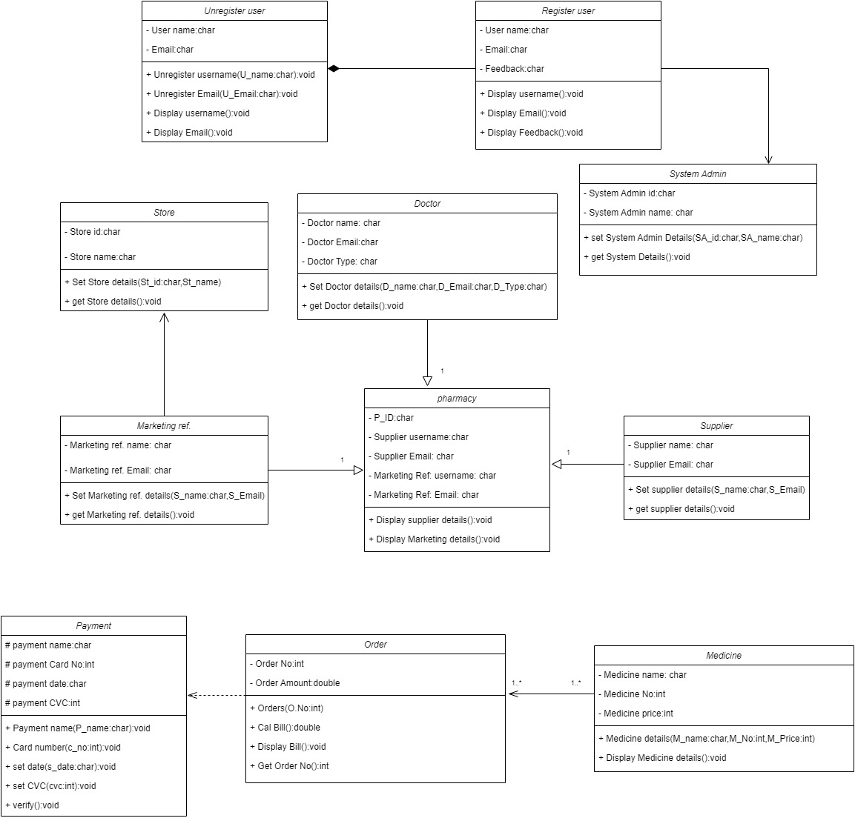

**Exercise 02**

Codes

//Doctor

#include<iostream>

using namespace std;

#include<cstring>

#include<iomanip>

class docter{

private:

char doctername[];

char email[];

char type[];

public:

docter();

docter(char name[],char email[],char type[]);

void getdoctername();

void getemail();

void gettype();

};

docter::docter(){

strcpy(doctername,"");

strcpy(email, "");

strcpy(type,"");

}

docter::docter(char name[],char email[],char type[]){

strcpy(doctername,name);

strcpy(email,email);

strcpy(type,type);

}

void docter::getdoctername(){

}

void docter::getemail(){

}

void docter::gettype(){

}

//Marketing ref.

class markerting_ref{

private:

char markertingref_name [10];

char markertingref_email [];

public:

markerting_ref();

markerting_ref( char m_ref_name[],char m_ref_email[]);

void getmarkerting_ref_name();

void getmarkerting_ref_email();

};

markerting_ref::markerting_ref()

{

strcpy(markertingref_name, "" );

strcpy(markertingref_email, "");

}

markerting_ref::markerting_ref( char m_ref_name [],char m_ref_email[])

{

strcpy(markertingref_name,m_ref_name);

strcpy(markertingref_email,m_ref_email);

}

void markerting_ref::getmarkerting_ref_name(){

}

void markerting_ref::getmarkerting_ref_email(){

}

//Medicine

class medicine{

private:

char medicinename[];

int medicine_no;

float price;

public:

medicine();

medicine(char medicinename[],int medicine_no,float price);

void getmedicinename();

void getmedicine_no();

void getprice();

};

medicine::medicine(){

strcpy(medicinename,"");

medicine_no =0;

price=0.0;

}

medicine::medicine(char medicinename[],int medicine_no,float price){

strcpy(medicinename,medicinename);

medicine_no=medicine_no;

price=price;

}

void medicine::getmedicinename(){

}

void medicine::getmedicine_no(){

}

void medicine::getprice(){

}

//Unregister User

class unregisteruser{

private:

char usename[20];

char email[];

public:

unregisteruser();

unregisteruser(char name[],char email[]);

void getusername();

void getemail();

};

unregisteruser::unregisteruser() {

strcpy(usename, "");

strcpy(email,"");

}

unregisteruser::unregisteruser(char name[],char email[]) {

strcpy(usename, name);

strcpy(email, email);

}

void unregisteruser::getusername(){

}

void unregisteruser::getemail(){

}

//Register user

class registeruser{

private:

char username[10];

char email[20];

char feedbacks[];

public:

registeruser();

registeruser(char name[],char email[],char feedbacks[]);

void getusername();

void getemail();

void getfeedbacks();

};

registeruser::registeruser(){

strcpy(username, "");

strcpy(email, "");

strcpy(feedbacks, "");

}

registeruser::registeruser(char name[],char email[],char feedbacks[])

{

strcpy(username ,name);

strcpy(email ,email);

strcpy(feedbacks, feedbacks);

}

void registeruser::getusername(){

}

void registeruser::getemail(){

}

void registeruser::getfeedbacks(){

}

//Order

class oder{

private:

int oder_number;

float amount;

public:

oder();

oder( int oder_number,float amount);

void getoder_number();

void getamount();

};

oder::oder()

{

oder_number=0;

amount=0.0;

}

oder::oder(int oder_number,float amount)

{

oder_number=oder_number;

amount=amount;

}

void oder::getoder_number(){

}

void oder::getamount(){

}

//System Admin

class systemadmin{

private:

char systemadmin_id[];

char systemadmin_name[];

public:

systemadmin();

systemadmin( char admin_id[10],char admin_name[]);

void getsystemadmin_id();

void getsystemadmin_name();

};

systemadmin::systemadmin()

{

strcpy(systemadmin_id,"");

strcpy(systemadmin_name, "");

}

systemadmin::systemadmin( char admin_id[10],char admin_name[])

{

strcpy(systemadmin_id,admin_id);

strcpy(systemadmin_name,admin_name);

}

void systemadmin::getsystemadmin_id(){

}

void systemadmin::getsystemadmin_name(){

}

//Supplier

class suplier{

private:

char suplier_name[];

char suplier_email[];

public:

suplier();

suplier( char suplier_name[],char suplier_email[]);

void getsuplier_name();

void getsuplier_email();

};

suplier::suplier()

{

strcpy(suplier_name,"");

strcpy(suplier_email, "");

}

suplier::suplier( char suplier_name[],char suplier_email[])

{

strcpy(suplier_name,suplier_name);

strcpy(suplier_email,suplier_email);

}

void suplier::getsuplier_name(){

}

void suplier::getsuplier_email(){

}

int main()

{

docter("Dr.Sadharas","Doctersadharas39@gmail.com","dentist");

markerting_ref("Kalum Pathirana","Kalumpathirana264@gmail.com");

medicine("Astholin400",678,645);

unregisteruser ("Ishara", "ishara@gmail.com");

registeruser("Nimesh Chanuka","ChanukaNimesh1999@gamil.com","Good servce++");

oder(45678,47500.00);

systemadmin("AD03567","Thushan alvis");

suplier("Sarath Pranandu","sarathpranndu24@gmail.com");

return 0;

};

Thank You…